OFFICIAL COORDINATION FOR
NON-ROUTINE OPERATIONS AND MAINTENANCE

NOTIFICATION DATE- 5 July 2011
PROJECT- Bonneville Lock and Dam
RESPONSE DATE- 14 July 2011 (FPOM)

Description of the problem- District mechanical engineers have requested Main Dam Gantry 6 gate hoist testing. The test includes raising spillgate 6 from the current position (3.9’) to a maximum of 20’. Once at 20’, the gate will be lowered to sill. This will be repeated at least twice, possibly three times.

Type of outage required- On 7 July, starting at 0830, the Control Room will begin raising spillgate 6, using Gantry 6, from the current 3.9’ to a maximum of 20’. GDACS will automatically adjust other spill gates to maintain the appropriate spill volume.

Impact on facility operation- The control room will control Gantry 6 remotely. GDACS will adjust the other gates to maintain the spill volume and use a pattern already programmed into the system. A District engineer will be on site to record the needed data every ½’ of gate position change.

Right now gate 6 is open 5’. This operation is consistent with debris flushes that occur throughout the year. At this spill, the adjustment to the other gates will be, roughly, a 1’ change in opening, if applied evenly across the spillway.

Length of time for repairs- The testing will start at 0830 on 7 July. It will conclude once Gantry 6 has raised and lowered spillgate 6 at least twice, maybe three times. One cycle is roughly 10-15 minutes.

Expected impacts on fish passage- Juvenile impacts are expected to be minimal since the test is going to occur during the day. Spill volume is not expected to change significantly as long as GDACS automatically adjusts the other gates.

According to the FPC graphs, the 95% of steelhead and yearling chinook have passed the project. We are entering the peak of sub-yearling chinook passage.
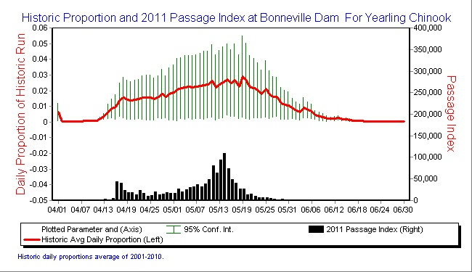
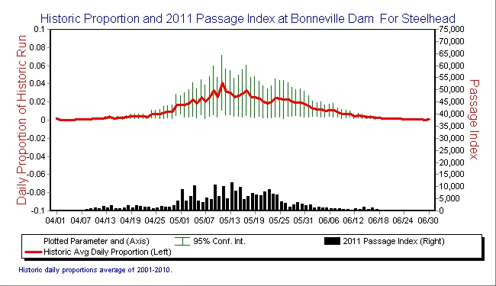

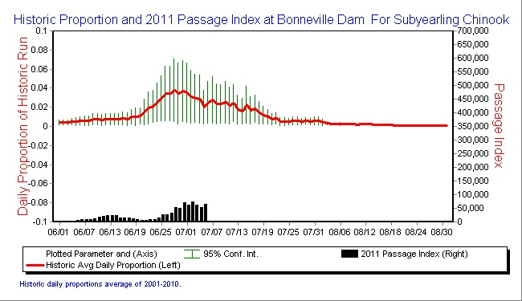

Adult impacts are also expected to be minimal even though testing will occur during the day; spill volume is not expected to change significantly. This should not increase the risk of fallback. Recent adult passage numbers are below.

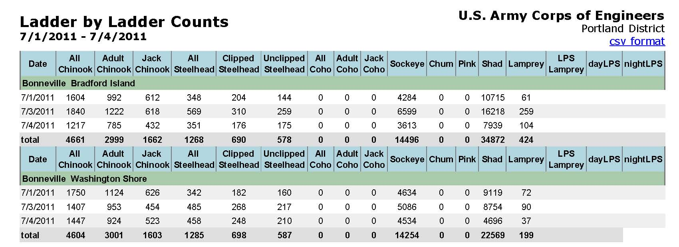

Comments from others
NWP- L. Ebner- All, The test as I understand it would lift spillway gate 6 at Bonneville (or whichever one is controlled by the north gantry crane) to an elevation of x and then back down. This will be repeated. The hoist loads will be recorded a half foot increments by hand or by computer. The gate will not be stopped during the test except to change directions and return the gate to the previous opening.

Maximum gate opening possible is 20 to 22 feet. This large of gate opening is consistent with debris cleaning operations. I would prefer that the gate opening be restricted to a maximum opening of 10 feet but no more than 15 feet. The spillway is already compromised and unnecessary risks should not be taken.

NOAA Fisheries- -----Original Message-----
From: Gary Fredricks [mailto:Gary.Fredricks@noaa.gov]
Sent: Wednesday, July 06, 2011 10:18 AM
To: Mackey, Tammy M NWP; Klatte, Bernard A NWP
Cc: Trevor Conder; Lorz, Tom; Dave Benner; Wills, Dave; Russ Kiefer; Kruger, Rick; Hausmann, Ben J NWP; Rerecich, Jonathan G NWP
Subject: Re: FPOM: Official coordination/notification- BON Gantry 6 spillgate hoist test

I can think of several reasons why this shouldn't be done as proposed. First, raising this gate and letting the other gates adjust will violate the FPP spill pattern which may have a negative effect on juvenile passage (which does occur during the day) by restricting the other gates to openings that may cause injury, second, an opening this large could easily cause fallback of adult salmon passing near the spillway (a behavior we know happens when fish are passing the Bradford Island Ladder) and third, an opening this large over a spillway apron which is not in the best of shape (as recently advised by the Corps Portland District) could cause long-term damage that we aren't currently prepared to deal with from a fish passage standpoint. Also, I believe the TDG monitor, which would be necessary to monitor the effects of this test on tailrace dissolved gas, is out of service. I didn't see any rationale as to why this test was being conducted and I didn't see any provision for emergency actions if the process should encounter problems, particularly with the gate open 22'. I would advise that the project postpone this action until the regional fish managers can have a discussion of these issues through the FPOM process. Thanks, Gary

CRITFC- -----Original Message-----
From: Tom Lorz [mailto:lort@critfc.org]
Sent: Wednesday, July 06, 2011 10:22 AM
To: Mackey, Tammy M NWP
Subject: Re: FPOM: Official coordination/notification- BON Gantry 6spillgate hoist test

Could you please provide more justification why this occurring now, and why it could not be done later? As of right now I am not in-favor of this operation and will need more information before I can sign off on this, I am concerned about the stilling basin and creating anymore damage especially with 22 ft open.

Thanks tom lorz

NWP-
-----Original Message-----
From: Hess, Matthew K NWP
Sent: Wednesday, July 06, 2011 11:49 AM
To: Mackey, Tammy M NWP; Perletti, Kevin P NWP; Hausmann, Ben J NWP; Rerecich, Jonathan G NWP; Schwartz, Dennis E NWP; Ebner, Laurie L NWP
Cc: Klatte, Bernard A NWP
Subject: RE: FPOM: Official coordination/notification- BON Gantry 6 spillgate hoist test

We currently have an AE working to design new hoists for the spill bays that do not have dedicated hoists. Questions have been raised about the condition of the gate rollers and their contribution to the hoist load. During inspections in the repair pit it's been observed that the gate rollers cannot be turned. Assumptions that the rollers have completely seized has lead to unreasonably large hoist loads. We have no practical way to measure the friction contribution of these rollers and therefore no way to accurately determine the new hoist design load. P&S for these new hoists has completely stopped because we have not been able to resolved this issue. The purpose of this test is to take measurements to determine the actual friction contributions of these gate rollers. This will allow us to determine the design hoist load and proceed with development of P&S for new hoists. We would like to get this issue resolved as soon as possible to be able to continue with the design. Operations has also expressed a desire to perform this test as soon as possible.

It is desirable from the Design Branch perspective to take hoist load measurements for as wide a range of gate opening as possible. However, we understand there are consequences with opening the gates too far. We would like to take hoist load measurements up to a minimum of a 20ft opening. This will allow us to capture the changing buoyancy effects as the flow control shifts from the gate lip to the lower edge of the upstream face of these gates (should start occurring at approximately 15ft gate opening). Again, we understand there are reasonable limits on the gate opening we can achieve. We are looking to other departments to express their concerns with this request so we can collectively determine a safe maximum gate opening to use for this test.

Thanks,
Matthew Hess
Mechanical Design Engineer
US Army Corps of Engineers
CENWP-EC-DM
503.808.4955

-----Original Message-----
From: Perletti, Kevin P NWP
Sent: Wednesday, July 06, 2011 12:01 PM
To: Hess, Matthew K NWP; Schwartz, Dennis E NWP; Ebner, Laurie L NWP
Cc: Klatte, Bernard A NWP; Mackey, Tammy M NWP; Hausmann, Ben J NWP; Rerecich, Jonathan G NWP
Subject: RE: FPOM: Official coordination/notification- BON Gantry 6 spillgate hoist test

Matt, et al,
If a lesser gate opening can provide adequate info for INCA design work I would recommend that you propose something like that. In any case Tammy or Dennis are probably the people you want to write the justification and any changes to what has been proposed so that they can coordinate with Gary.

From the Bonneville Project perspective we have more flow now so it is easier for us to make gate adjustments to maintain flow through the spillway. If we wait to do this later, when there is less flow in the river we have less flexibility to make adjustments. It is understood that the FPP is the rule for spill flow and pattern.

Kevin P. Perletti P.E.
Mechanical Engineer
Bonneville Lock and Dam
Cascade Locks, OR. 97014
541-374-4572
541-374-8761 Fax
kevin.p.perletti@usace.army.mil

July 2011 FPOM- Fredricks expressed concerns about needing to replace rollers. He also expressed concern about damaging the apron and not having any spill pattern to address that condition. Schwartz suggested setting a maximum opening. Fredricks asked about a contingency plan if the gate sticks. Fredricks suggests 15’ maximum and gate compensation should not go below 2’. Three cycles is permitted.

Final results- Approved at the July 2011 FPOM. Testing occurred as coordinated with a 15’ maximum opening, GDACS gate compensation won’t go below 2’ openings and the gate may be cycled three times. This will occur on 18 July.

Please email or call with questions or concerns.
Thank you,
Tammy Mackey
NWP Operations Division Fishery Section
Columbia River Coordination Biologist
503-961-5733 Blackberry
Tammy.m.mackey@usace.army.mil

